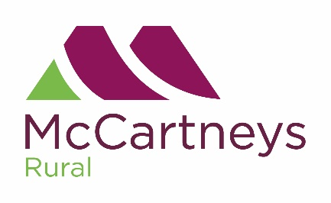

**McCartneys Horse & Pony Sale**

**At The Royal Welsh Showground**

On Monday 17th October 2022 at 11.00am

**Sale of**

**STANDARDBRED HORSES**

Entries close for all Sections

on Friday 23rd September 2022

*Further details and entry forms:*

McCartneys Horse & Pony Department

The Livestock Market, Warren Road, Brecon, LD3 8EX

01874 622386 or 07815 743478

breconmarket@mccartneys.co.uk